Contract Management

Contents

Contract Management user guide 2

About 2

Database organization 2

Code organization 3

Client user interface 3

Login page 4

Admin panel 4

Manager panel 5

Managers table 5

Manager details 6

User table 6

User details 7

Contract types 7

Create contract type 8

Contract details 8

Contract requests 9

Audits 10

Mail configuration 11

# Contract Management user guide

## About

Contract management is web-based application written in C# under ASP.NET 4.6.1 platform. It’s centralized database oriented, hosted on Azure service. Client is also web oriented solution under ASP.NET MVC platform. Also hosted on Azure cloud system.

Main parts of the web application:

* Database (Entity framework based, code-first)
* Database Services (All operations connected with database)
* Services (External services used for backup/export database tables and mailer)

## Database organization

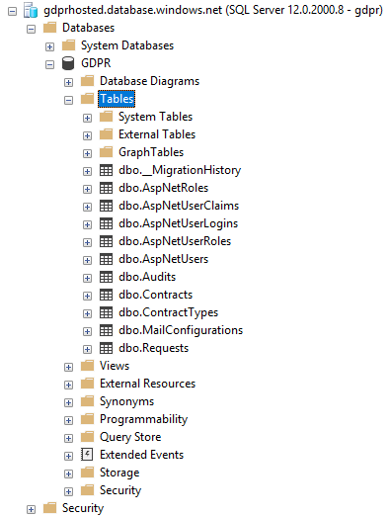

Database is organized in several tables such as:

* Contracts
* Requests
* Contract types
* Mail Configuration
* Identity tables (AspNetRoles, AspNetUserClaims, AspNetLogins, AspNetUserRoles, AspNetUSers)
* Audits (log action table)
* Migration table for entity framework database

## Code organization

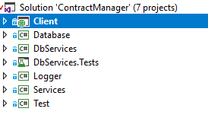

Application is developed in Visual Studio 2017. It consist of several project of which:

* Client (MVC based web client)
* Database (Code-first entity framework class library)
* DbServices (Database Services, class library)
* DbServices.Tests (Database Services unit tests, unit test project)
* Logger (log4net based logger, class library)
* Services (External services, class library)
* Test (Console test application, debug and development purposes)

## Client user interface

Users in contract management application are separated in 3 role based user types

* Admin
* Contract manager
* Contract user

Admin user is specific user creating in purpose for

* exporting database as dump,
* create contract manager users
* view all contract managers
* view all contract requests
* view all users
* view all contract types
* view all action by contract managers in audits
* configure mailer

Contract users can provide:

* create end user
* create contract type
* view users
* view contract types
* send user contract
* view their specific audits

End users can provide:

* login to system
* watch their contracts

### Login page

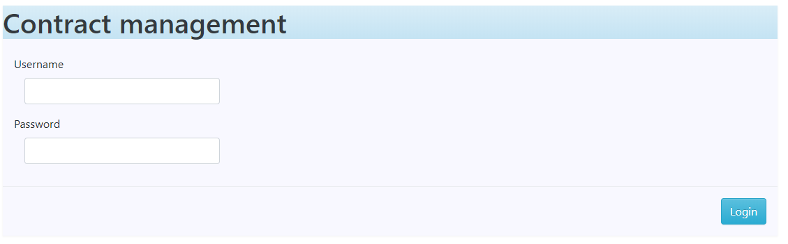

### Admin panel

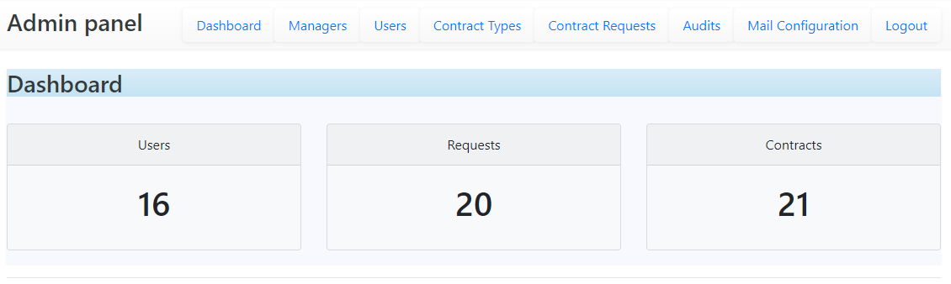

Dashboard is specific overall page for showing statistics about all users, requests and contracts. Admin and contract users have their dashboard related with their users.

### Manager panel

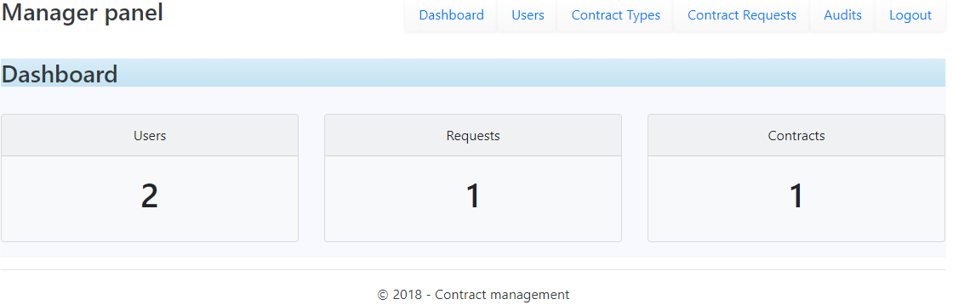

### Managers table

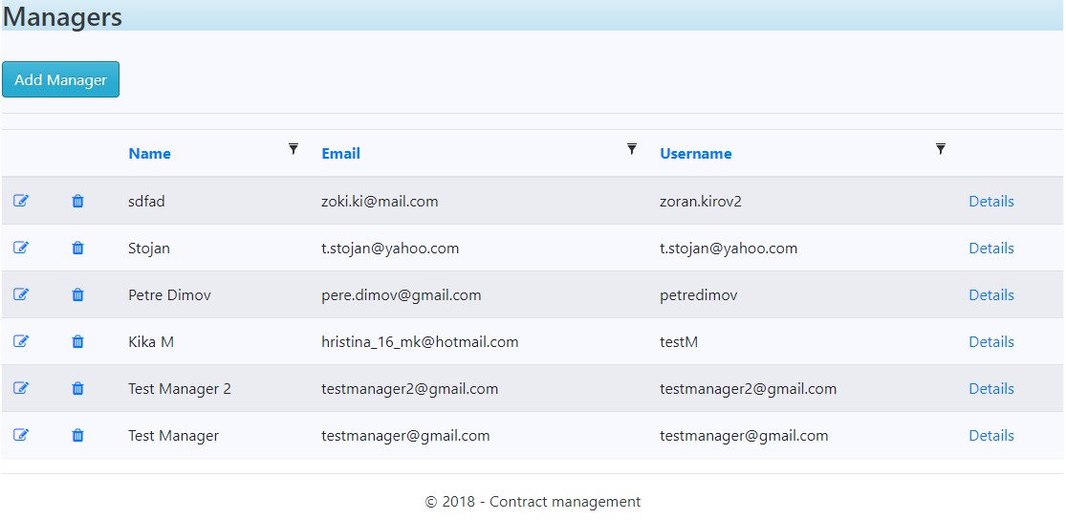

Table based view that only admins can see.

### Manager details

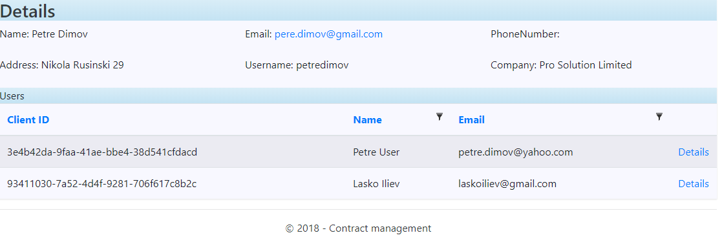

Manager details is admin view. It’s showing the manager in depth with their specific users.

### User table

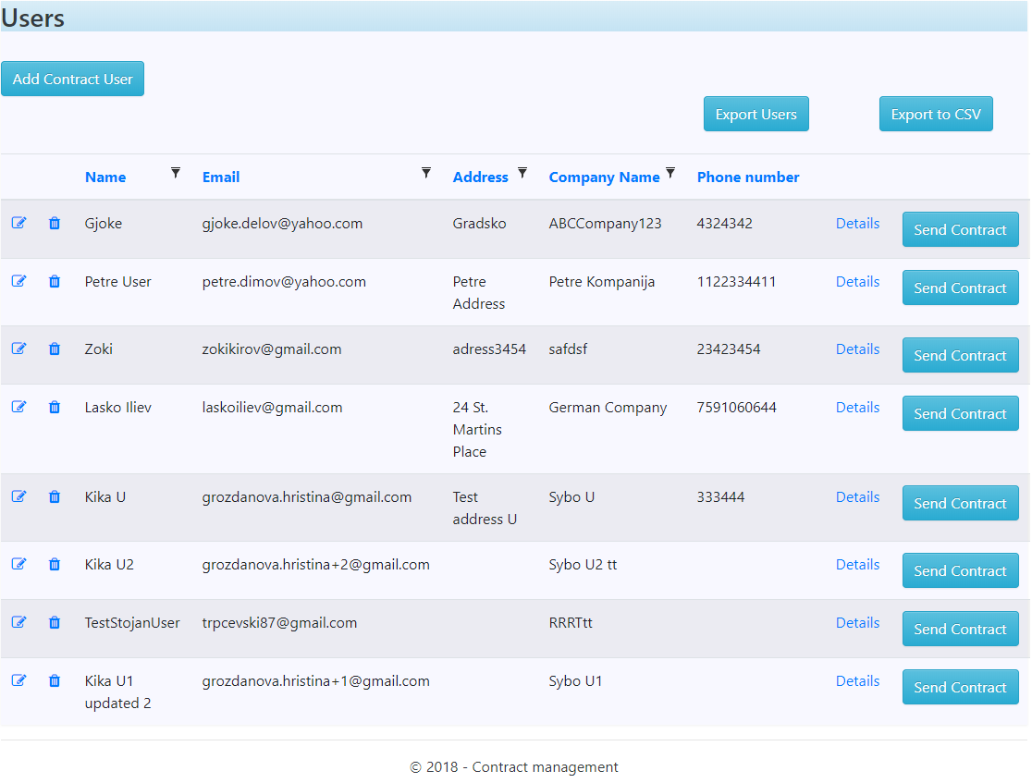

Tabled based view with all user or specific user for contract manager. Admin can see all users in this view, however, contract manager can see only their specific users.

### User details

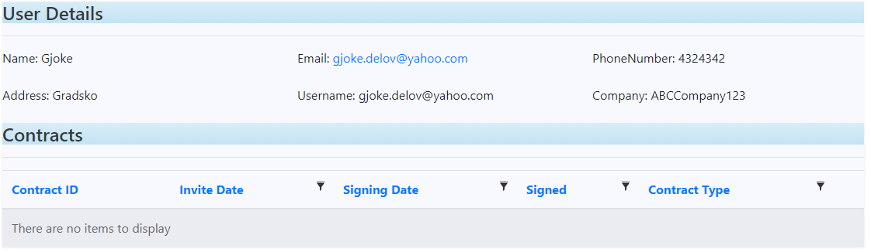

User details with all contracts.

### Contract types

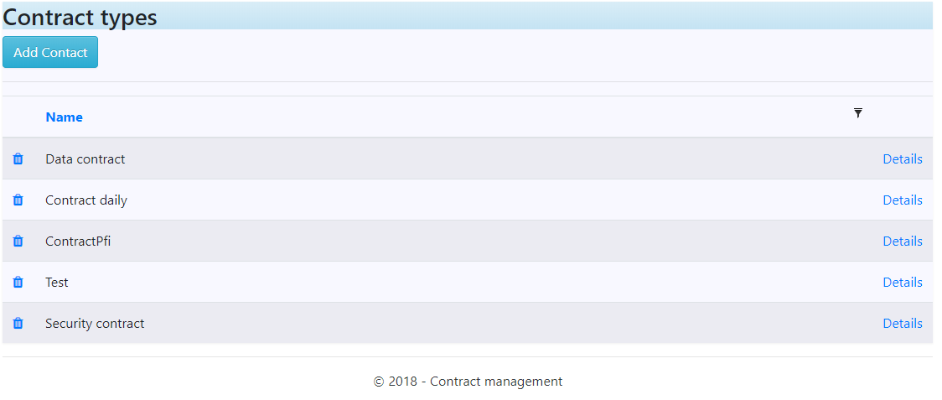

Table based view for specific contract types. Admin users can see all contract types, contract manager can see just their specific contract types.

### Create contract type

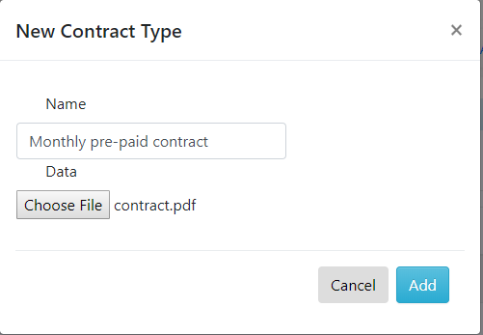

### Contract details

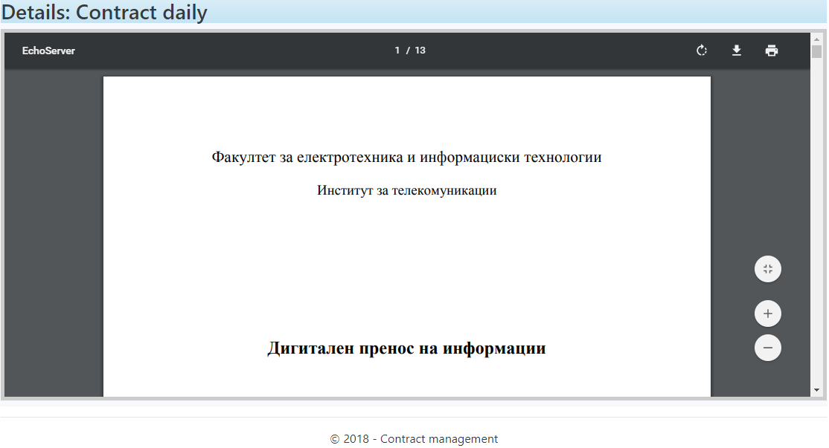

Pdf viewer for seeing specific contract details.

### Contract requests

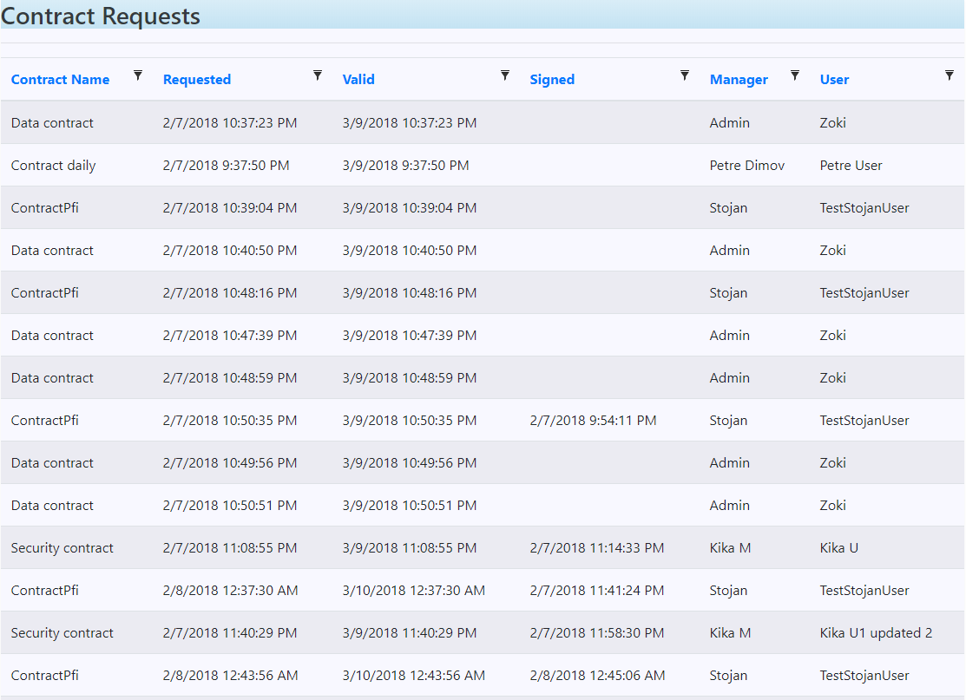

Table based view for every contract request with:

* Contract name,
* Requested date,
* Valid date,
* Signed date,
* Contracted by (Manager)
* Signed by (User)

### Audits

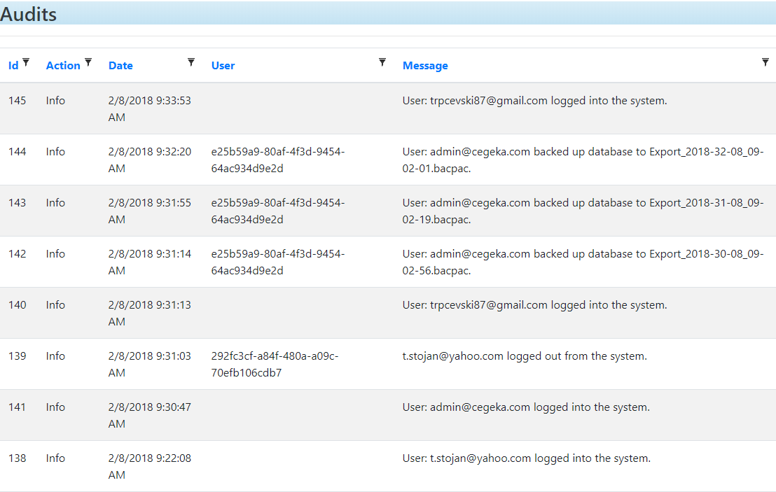

Audits are used to store all the action of the contract manager users and end users in the database. It’s kind of history for the application and actions of the users that are using the application.

### Mail configuration

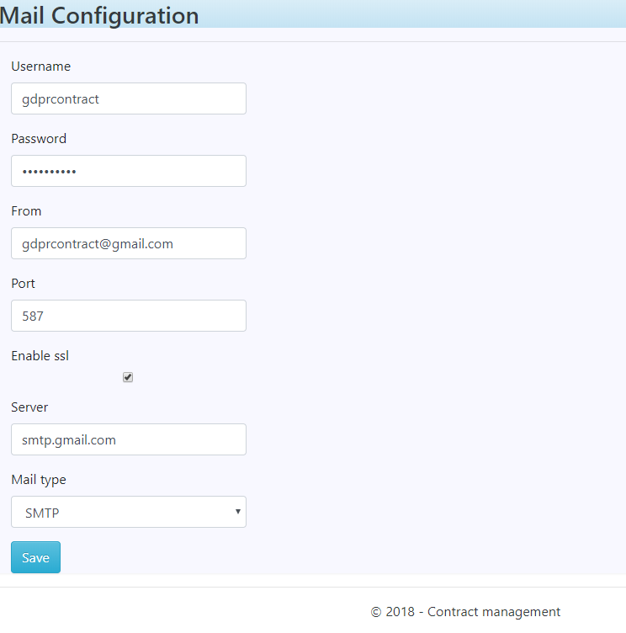

Mail configuration is form that is used to configure the specific mail that will send notification to clients and contract managers. It support SMTP/Exchanges mail types with SSL. There is a default predefined mail already with the application. This mail can be edited.